Project Design Phase-II
Data Flow Diagram & User Stories

Date
  03 October 2026
Team ID | SWTID-2026-8726
Project Name | Auto Ticket Classification using FLOW DESIGNER
Maximum Marks | 4 Marks

Data Flow Diagrams
A Data Flow Diagram (DFD) represents how information moves through the Auto Ticket Classification using FLOW DESIGNER system. It shows how a support ticket enters the system, how the ticket information is evaluated and classified, how the appropriate category, priority and assignment group are determined, and how the processed ticket is routed to the support team.
The system receives newly created incident or service-request records and evaluates information such as the ticket description, requester profile and channel source. Flow Designer then applies conditional rules to classify and route the ticket.
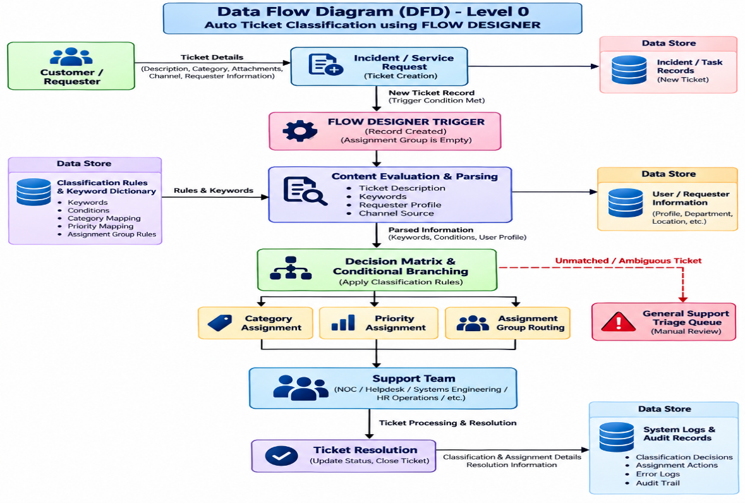

User Stories
The following user stories are structured using the same fields as the provided sample: User Type, Functional Requirement (Epic), User Story Number, User Story / Task, Acceptance Criteria, Priority and Release.
User Type | Functional Requirement (Epic) | User Story Number | User Story / Task | Acceptance Criteria | Priority | Release
Customer / Requester | Ticket Submission | USN-1 | As a requester, I can submit an incident or service request with the required ticket details. | Ticket record is successfully created. | High | Sprint-1
Service Desk Agent | Automatic Trigger | USN-2 | As a service desk agent, I want the classification flow to start automatically when a new ticket is created. | Flow is triggered when a new ticket is created and assignment group is empty. | High | Sprint-1
Service Desk Agent | Content Evaluation | USN-3 | As a service desk agent, I want the system to analyze the ticket description and relevant requester information. | Ticket content and requester information are evaluated by the workflow. | High | Sprint-1
Service Desk Agent | Ticket Classification | USN-4 | As a service desk agent, I want the system to identify the appropriate ticket category using predefined keywords and conditions. | Matching keywords/conditions result in the appropriate category. | High | Sprint-1
Service Desk Agent | Priority Assignment | USN-5 | As a service desk agent, I want the system to automatically determine the ticket priority. | Appropriate priority level is assigned according to the configured rules. | High | Sprint-1
Support Team | Automatic Routing | USN-6 | As a support team member, I want tickets to be automatically assigned to the appropriate support group. | Classified ticket is routed to the configured assignment group. | High | Sprint-1
Service Desk Agent | Conditional Routing | USN-7 | As a service desk agent, I want different ticket conditions to follow different Flow Designer branches. | Matching conditions execute the correct branch and action. | High | Sprint-2
Service Desk Agent | Fallback Handling | USN-8 | As a service desk agent, I want unmatched tickets to be sent to a General Support Triage Queue. | Unmatched tickets are routed to the fallback queue instead of being dropped. | High | Sprint-2
Service Desk Supervisor | Classification Notification | USN-9 | As a supervisor, I want to receive a notification when a ticket cannot be automatically classified. | Classification anomaly generates a notification for manual review. | Medium | Sprint-2
Service Desk Administrator | Error Handling | USN-10 | As an administrator, I want workflow and database errors to be logged without stopping the overall system. | Error information is captured in system logs. | High | Sprint-2
Service Desk Administrator | Audit Trail | USN-11 | As an administrator, I want classification and assignment actions to be recorded for auditing. | Classification decisions and assignment actions are logged. | Medium | Sprint-2
Service Desk Administrator | Rule Maintenance | USN-12 | As an administrator, I want to modify classification rules through Flow Designer without rebuilding the complete system. | Rules can be maintained through the visual workflow configuration. | Medium | Sprint-3
The first implementation stories are directly supported by the project's documented trigger, content evaluation, conditional branching, category assignment, priority assignment and routing design

Future Enhancement User Stories
The project also identifies future enhancements including Machine Learning Integration, Sentiment Analysis, Multi-Language Support and Dynamic Load Balancing.
User Type | Functional Requirement (Epic) | User Story Number | User Story / Task | Acceptance Criteria | Priority | Release
Administrator | Machine Learning | USN-13 | As an administrator, I want predictive classification using historical ticket data. | System can classify tickets based on learned patterns. | Low | Sprint-4
Service Desk Supervisor | Sentiment Analysis | USN-14 | As a supervisor, I want customer sentiment to be considered during ticket prioritization. | Sentiment information can influence escalation rules. | Low | Sprint-4
Customer / Requester | Multi-Language Support | USN-15 | As a requester, I want tickets submitted in different languages to be classified. | Supported languages can be processed and classified. | Low | Sprint-5
Service Desk Administrator | Dynamic Load Balancing | USN-16 | As an administrator, I want tickets to consider agent availability and workload during assignment. | Tickets can be distributed based on available support capacity. | Low | Sprint-5
User Type | Functional Requirement (Epic) | User Story Number | User Story / Task | Acceptance Criteria | Priority | Release
Administrator | Machine Learning | USN-13 | As an administrator, I want predictive classification using historical ticket data. | System can classify tickets based on learned patterns. | Low | Sprint-4
Service Desk Supervisor | Sentiment Analysis | USN-14 | As a supervisor, I want customer sentiment to be considered during ticket prioritization. | Sentiment information can influence escalation rules. | Low | Sprint-4
Customer / Requester | Multi-Language Support | USN-15 | As a requester, I want tickets submitted in different languages to be classified. | Supported languages can be processed and classified. | Low | Sprint-5
Service Desk Administrator | Dynamic Load Balancing | USN-16 | As an administrator, I want tickets to consider agent availability and workload during assignment. | Tickets can be distributed based on available support capacity. | Low | Sprint-5
User Type | Functional Requirement (Epic) | User Story Number | User Story / Task | Acceptance Criteria | Priority | Release
Administrator | Machine Learning | USN-13 | As an administrator, I want predictive classification using historical ticket data. | System can classify tickets based on learned patterns. | Low | Sprint-4
Service Desk Supervisor | Sentiment Analysis | USN-14 | As a supervisor, I want customer sentiment to be considered during ticket prioritization. | Sentiment information can influence escalation rules. | Low | Sprint-4

